# Softuniada 2019

## Grid Voyage

*Doctor Sanity’s pet pokemon – Slifer, is training his sense of direction with a game that Doc designed for him, called Grid Voyage. You should help Slifer, as he is not the smartest pokemon in existence. Try to write an algorithm which simulates the Grid Voyage game.*

You will be given **N** – an **integer**. You must create a 2-D matrix of integers with **N rows** and **N columns**, each cell with value – 0. You will then receive the **coordinates** of the **start point**.

Afterwards, you will start receiving lines, containing **coordinates** of a **destination point**, the **initial direction** (left, right, up, down) and **current stamina**. You must **reach** the **destination point** doing a grid-based movement, only changing directions when you run out of stamina.

* You consume **1 stamina** per **step** (per **cell movement**).
* When you run out of **stamina**, you **MUST** **change** the **direction** and **reset** your **stamina**.
* You must **increase** the **value** of **each cell** you **step on** with **1**.

**Example**: Initial position – [0, 0].

First destination [2, 2]. Initial direction – down. Stamina – 2.

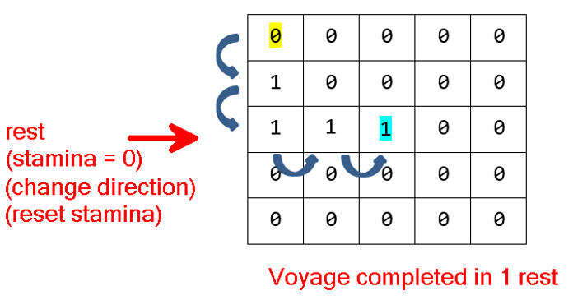

Slifer is always looking for the **fastest path**, which means that he should **always move** in directions, **towards** his **next destination**.

Slifer is fat – he can **ONLY turn left** or **right**. He **CANNOT** completely **turn around** in a reversed direction.

Slifer possesses a bit of intellect – if he is in a **dilemma** (he can go several directions, and all of them are leading to his target), he will try to **turn LEFT first**.

* If he **cannot** **turn left** (not enough space in matrix, to make the needed steps before the next change in direction), he will try to **turn right**.
* If he **can** turn **neither left**, **nor right**, he will deem the current Voyage – **impossible** and return to his previous position. In this case, there should be **NO cells** **affected** by **increased value**.

If it **is possible** to reach the destination, you must print **how** **many rests** (how many times you’ve **ran out** of **stamina** and you’ve **changed direction**) Slifer took to reach it. If it is **NOT possible** to reach the destination, you must print "Voyage impossible".

When you receive the command "eastern odyssey", the input sequence should end, and you should print the **whole matrix**.

### Input

The input consists of several input lines:

* On the **first** input line you will receive **N** – the **dimensions** of the 2-D matrix.
* On the **second** input line you will receive **X** and **Y**, separated by a **space** – the **initial position** of Slifer.
* On the next **several** input lines you will receive **coordinates** of a **destination point**, a **direction** and **stamina** in the following format: {destinationX} {destinationY} {direction} {stamina}
* When you receive the command "eastern odyssey", the input sequence should end.

### Output

As output you must print:

* For **every voyage**:
  + If it is **possible**, the number of **rests** it took to **reach** the **destination point**.
  + If it is **NOT possible** – you should print "Voyage impossible".
* At the end of the program:
  + The **whole** **matrix** – each **row** on a **new line**, each **column** separated by a **space**, from the others.

### Constraints

* The integer **N** will be in **range [0, 50]**.
* The **coordinates** of the **initial point** and **destination points** will **always** be **VALID** and inside the matrix.
* The **directions** will **always** be **valid**.
* The **stamina** will always be in **range** **[1, 50]**.

### Examples

|  |  |  |
| --- | --- | --- |
| ****Input**** | ****Output**** | ****Comment**** |
| **5**  **0 0**  **2 2 down 2**  **4 4 right 1**  **eastern odyssey** | **1**  **3**  **0 0 0 0 0**  **1 0 0 0 0**  **1 1 1 1 0**  **0 0 0 1 1**  **0 0 0 0 1** | First Voyage:    Second Voyage:    The stamina is 1 this time. We must change direction after each step. |
| **7**  **3 3**  **5 5 left 2**  **6 6 right 2**  **eastern odyssey** | **5**  **Voyage impossible**  **0 0 0 0 0 0 0**  **0 0 0 0 0 0 0**  **0 0 0 0 0 0 0**  **0 1 1 1 1 1 0**  **0 1 0 1 0 1 0**  **0 1 1 1 0 1 0**  **0 0 0 0 0 0 0** |  |